

Analyzing the marketing condition of Airbnb

NAME: PANJALA SAISHRUTHI
02048455
MULTIVARIENT AND REGRESSION MODEL
MSIS 642 (Fall 2023)

Abstract
Online rental American company is selected to obtain the marketing strategies and finding the rental trends, as well as customer satisfaction helps to meet the requirements of the study. The hypothesis is selected to collect data regarding the variables of the dataset. A brief review of the literature took place to understand the previous research regarding the topic for the concerned company. Data analysis and data visualization processes are used to obtain the trends of the analysis. Regression models are implemented between the variables of the dataset for testing the hypothesis using R programming language. All activities have been thoroughly discussed based on the data and hypothesis mentioned.

Table of Contents
Introduction 4
Literature review 4
Theory and hypotheses 6
Data 6
Empirical approach 14
Results 15
Discussion and conclusion 16
References 18
Appendix 20

Introduction
Airbnb provides an online marketing service that helps to connect more people by renting their properties with people. The headquarters of the American company is in San Francisco and the employee strength of their offices was 2800 all over the world in 2021 (Annualreports, 2021). In the COVID-19 period, the revenue growth of the Company was reduced and long-term strategies such as improving the brand quality, innovative platform, and the effective hosting process helped to improve the business process. The global platform helps to improve the operational activities of the company which plays a significant role in enhancing the revenue growth of the company. The study helps to evaluate the patterns that allow for obtaining the unveiled valuable trends of the hospitality industry. The trends help to understand the required variables for evaluating the pricing strategy, host engagement, and guest satisfaction. R programming language is going to be used to analyze the marketing condition of Airbnb using data visualization and implementing the data models.

Literature review
The Airbnb site offers many hosts a golden opportunity to register for more than one property listing unit. As per the views of Wijaya et al., (2023), Airbnb is a trusted marketing community that enables anyone to list, search and book unique lodgings in over 20 cities around the world. The Airbnb site charges a 3% booking commission, but the fee only applies to accommodation service users. The supplier or host enjoys bargaining power on the website using the power against other participants from the industry to reduce product price and quality.
Airbnb’s platform showed that an increase in the number of rooms listed on its service is correlated with a decrease in hotel revenues. Lin et al., (2019) argued that Airbnb is an alternative supplier and provides other choices besides goods and services offered by long-standing accommodation industries. Tourists can receive an authentic, interactive experience by interacting with their hosts through the Internet with many diverse products and services offered at affordable prices. These experiences lead to a lot of people going on the road, promoting frequent travel activity that is extended in duration and widening tourism activities available.

Figure 1: Digital marketing strategy of Airbnb
(Source: Influenced by Adamiak, 2022)
The market success of Airbnb is rooted in the creative development of several recently devised ideas about tourism accommodation distribution. Based on the views of Adamiak (2022), the two-sided market model is exploited by Airbnb, which attracts providers of accommodation and tourists onto the platform. Airbnb started using online platforms as the market for holiday rentals of homes and apartments ballooned. Ultimately Airbnb’s development occurred together with the doing of a sharing economy, carried out on principles similar to those practiced by non-profit online hospitality networks “HomeExchange” and “Couchsurfing”.
The most important two-sided digital, peer-to-peer market in the area of accommodation industry is that of Airbnb. As per the views of Lladós-Masllorens, Meseguer-Artola & Rodríguez-Ardura, (2020), pricing is an area of emerging research on peer-to-peer digital marketplaces. Empirical studies frequently utilize large datasets extracted from Airbnb. According to guests’ demands, prices on Airbnb match accommodation offered by consumers. Airbnb incorporates an aggregator business model and it does not have a linear one similar to major hotel chains. As argued by Tsourgiannis & Valsamidis, (2019), it takes commissions from both the host and guest on every booking. The goal is to provide travelers with a sense of community with locals and make them feel right at home.

Theory and hypotheses
Null hypothesis (H0): There is not a significant relationship between the price of Apartment/home listing in Albany and the review.
Alternative hypothesis (H1): There is a significant relationship between the price of Apartment/home listing in Albany and the review.
The statistical analysis method is allowed to determine the relationship between the price and review which helps to explain whether the review of the guests affects the prices of the house or not. An effective software tool “R-studio” helps to obtain a significant relationship for gathering data regarding the hypothesis testing.

Data
The dataset used for analysis shows summary information and metrics of the listings of the concerned company. The data has been extracted from a reliable and valid source in which quarterly data from each region are available.
Data source: “http://insideairbnb.com/get-the-data/”.
391 attributes from the dataset shed light on parameters such as price, host details, review details, location and many more. The columns related to review are required to be looked after the most so that their impact on the pricing can be determined.
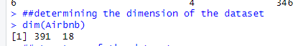
Figure 2: Determining the dimensions of the dataset
In the dataset, 18 columns and 391 rows are presented and dim() function is used.
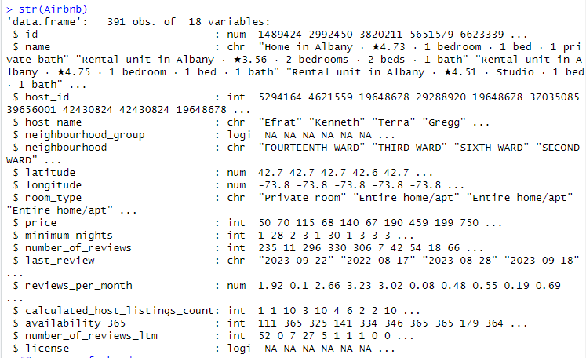
Figure 3: Obtaining the structure of the dataset
str() function is applied to find out the data types of the entire column that helps to collect information about the Airbnb dataset of Albany. In this case, it has been seen that the neighbourhood_group and license columns have no data to explain the dataset.
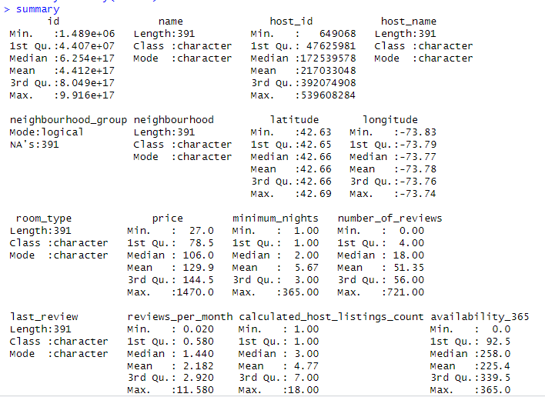
Figure 4: Finding the descriptive statistics
summary() function is used to collect information about the entire columns of the dataset and this function allows for obtaining the data patterns to enhance the performance.
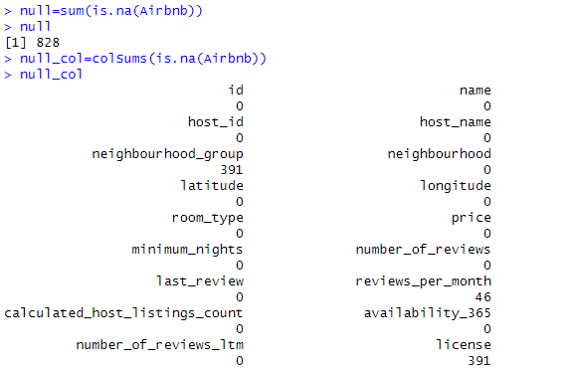
Figure 5: Calculating the null values
828 null values are calculated in all the columns of the dataset and the null values are needed to remove for increasing the effectiveness of the entire function.
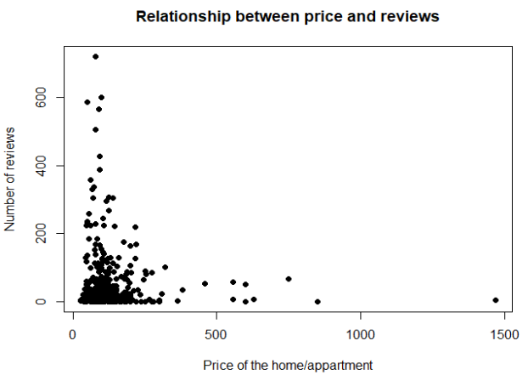
Figure 6: Evaluating the relationship between the variables
The above scatter plot is used for finding the relationship between number_of_reviews and price.
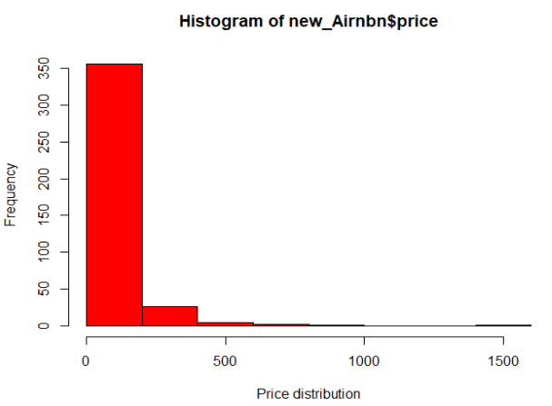
Figure 7: Histogram
The histogram plot is used for obtaining the data distribution of price variables.
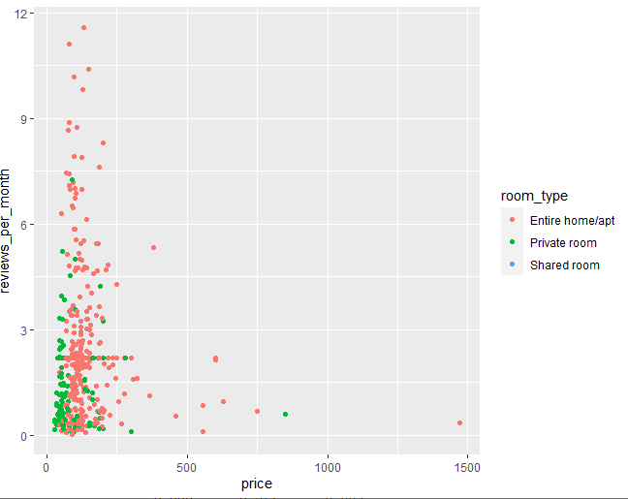
Figure 8: Scatter plot
Price and reviews_per_month are used to find out the relationship based on the room_type variable.
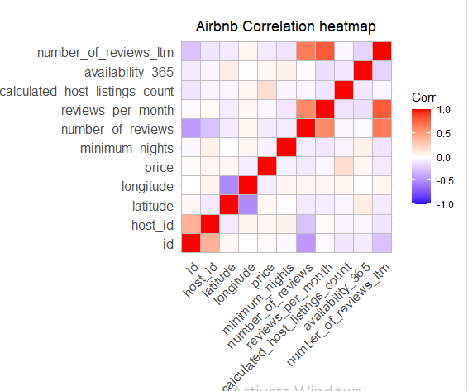
Figure 9: Heatmap
The heatmap is applied to obtain the relationship between the numerical variables of the dataset. The positive correlation denotes a strong relationship and the negative correlation denotes a weak relationship (Lim & Lauw, 2023). In this case, the colour of the heatmap identifies the relationship between the variables.

Empirical approach
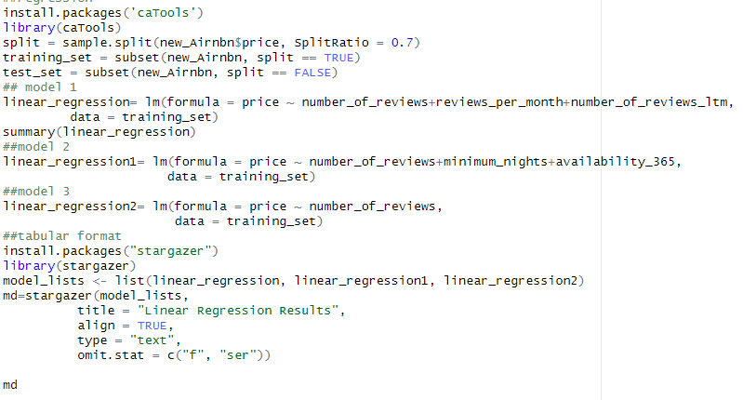
Figure 10: Implementation of regression models
Required library functions are used to maintain the training and testing procedure and a 0.7 split ratio is used to obtain the outcomes. In such circumstances, three linear regression models are implemented to collect information about the Hypothesis test.
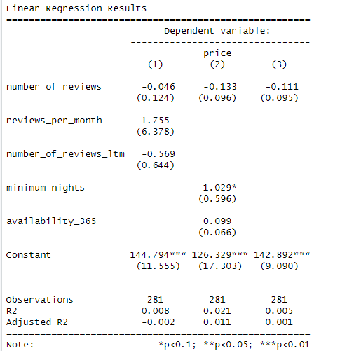
Figure 11: Outcomes of the linear regression
The output of the three regression models is shown in tabular format using Stargazer. The tabular format allows for evaluating the outcomes regarding the hypothesis test. The analytical model helps to obtain the predicted price of the rental home/apartment based on the review.

Results
In this analysis, descriptive statistics is used to obtain the data trends and patterns of the variables. The scatter plot explains increasing the price of Apartment is inversely proportional to the number of reviews. Almost 200 reviews are collected from the less than 500 prices of homes. Less than 500 prices of home/apartment are booked and the histogram of the price variable allows for determining the data distribution and the visualisation determines data trends based on the variables. The entire home/apartment was booked more than the private and shared room. In the visualisation, shared room was not observed to book and in this case, more data is required to analyse the outcomes.
In the correlation, the price of home/apartment has no positive relationship found against the reviews columns. Hence, it can be said that the null hypothesis cannot be rejected in this case. After that three regression models are implemented and the first regression model is implemented between the price and number_of_reviews, reviews_per_month and number_of_reviews_ltm. The second regression model is implemented between price and number_of_reviews, minimum_nights, and availability_365, as well as third regression model is implemented between the price and number_of_reviews. In three cases, the R-squared value and adjusted R values are almost 0. This identifies the overall three models as not statistically significant. Moreover, it does not provide sufficient information to reject the null hypothesis from the above test. Therefore, the above statistical test does not support the alternative hypothesis as the linear relationship is not found between the predictor values and response variables of the analysis. Statistical models cannot provide practical significance as the relationship is not found in the real world. Hence, other models are required to be implemented to collect data or more additional columns are required to explain the relationship between them.

Discussion and conclusion
Discussion
The discussion section focuses on the observed relationships between variables and their implications. The analysis pointed up an interesting inverse relationship between price and the number of reviews. However, this link was not statistically significant in any of the regression models and therefore did not confirm the alternative hypothesis. It suggests that more variables or different models are required to untangle the complex nature of pricing strategies and guest feedback. Such findings highlight the need for an understanding which transcends linear statistics. Understanding hidden patterns may be crucial for pricing strategies and guest satisfaction. Exploring unaccounted variables or more complex models could do the trick. More studies on issues such as host involvement, location details or listing characteristics may clarify the above complexities. Bringing these factors into analyses might help finesse predictions and provide tangible guidance for Airbnb’s pricing strategies, thus strengthening its position in the hospitality market.
Conclusion
Using R programming, the marketing of Airbnb has been looked into and some intriguing things regarding accommodation pricing and guest review work have been discovered. The analysis brought to light an unexpected absence of strong linear correlations between price and guest reviews for the same accommodation across different statistical models. It points to the incorporation of further variables or the use of advanced models in an attempt to tease out the fine details. Absent a connection between price and reviews compels further research into unknown variables, like host interaction level, location details or the special attributes of listing. It can be concluded that the study calls for more subtle analyses to understand the complex mix between pricing strategies and guest reviews.

References
Adamiak, C. (2022). Current state and development of Airbnb accommodation offer in 167 countries. Current Issues in Tourism, 25(19), 3131-3149. https://doi.org/10.1080/13683500.2019.1696758
Annualreports, (2021). UNITED STATES SECURITIES AND EXCHANGE COMMISSION WASHINGTON, D.C. 20549. Retrieved from: https://www.annualreports.com/HostedData/AnnualReportArchive/a/NASDAQ_ABNB_2021.pdf retrieved on: 18 December 2023
Lim, J. P., & Lauw, H. (2023, July). Large-scale correlation analysis of automated metrics for topic models. In Proceedings of the 61st Annual Meeting of the Association for Computational Linguistics (Volume 1: Long Papers) (pp. 13874-13898). Retrieved from: https://aclanthology.org/2023.acl-long.776/ retrieved on: 18 December 2023
Lin, P. M., Qiu Zhang, H., Hung, K., Lin, B., & Fan, D. X. (2019). Stakeholders’ views of travelers’ choice of Airbnb. Journal of Travel & Tourism Marketing, 36(9), 1037-1049. https://doi.org/10.1080/10548408.2019.1687390
Lladós-Masllorens, J., Meseguer-Artola, A., & Rodríguez-Ardura, I. (2020). Understanding peer-to-peer, two-sided digital marketplaces: pricing lessons from Airbnb in Barcelona. Sustainability, 12(13), 5229. doi:10.3390/su12135229
Tsourgiannis, L., & Valsamidis, S. (2019). Digital marketing in tourism: why Greek tourists use digital marketing applications like Airbnb. International Journal of Culture, Tourism and Hospitality Research, 13(4), 473-486.
Wijaya, I. N. M., Oka, I. M. D., Murni, N. G. N. S., & Darmayanti, P. W. (2023). E-Marketing in Accommodation Business Model Innovation at Airbnb in Bali. Jurnal Ilmiah Hospitality Management, 13(2), 119-126. https://doi.org/10.22334/jihm.v13i2

Appendix
install.packages("readr")
library("readr")
##import dataset
Airbnb <- read.csv("E:/data/listings.csv", header=TRUE)
##showing the dataset
head(Airbnb)
##determining the dimension of the dataset
dim(Airbnb)
##structure of the dataset
str(Airbnb)

##Summary of the dataset
summary=summary(Airbnb)
summary
##check null values
null=sum(is.na(Airbnb))
null

null_col=colSums(is.na(Airbnb))
null_col

##Remove null values
new_Airnbn = subset(Airbnb, select = -c(license,neighbourhood_group) )
new_Airnbn$reviews_per_month[is.na(new_Airnbn$reviews_per_month)] <- mean(new_Airnbn$reviews_per_month, na.rm = TRUE)
colSums(is.na(new_Airnbn))
###Graphical analysis
install.packages("ggplot2")
library(ggplot2)

##Scatter plot
plot(new_Airnbn$price , new_Airnbn$number_of_reviews,
main ="Relationship between price and reviews",
xlab ="Price of the home/appartment",
ylab =" Number of reviews ", pch = 19)

##histogram
hist(new_Airnbn$price, xlab = "Price distribution",
col = "red", border = "black")

##Scatter plot
ggplot(new_Airnbn,aes(x=price,y=reviews_per_month,group=room_type))+
geom_point(aes(color=room_type))

##Correlation
Airbnb_correlation =cor(new_Airnbn[sapply(new_Airnbn,is.numeric)])
Airbnb_correlation
install.packages("ggcorrplot")
library(ggcorrplot)
correlation=ggcorrplot(Airbnb_correlation)+
labs(title = "Airbnb Correlation heatmap")+
theme(plot.title = element_text(hjust = 0.5))
correlation
##regression
install.packages('caTools')
library(caTools)
split = sample.split(new_Airnbn$price, SplitRatio = 0.7)
training_set = subset(new_Airnbn, split == TRUE)
test_set = subset(new_Airnbn, split == FALSE)
## model 1
linear_regression= lm(formula = price ~ number_of_reviews+reviews_per_month+number_of_reviews_ltm,
data = training_set)
summary(linear_regression)
##model 2
linear_regression1= lm(formula = price ~ number_of_reviews+minimum_nights+availability_365,
data = training_set)
##model 3
linear_regression2= lm(formula = price ~ number_of_reviews,
data = training_set)
##tabular format
install.packages("stargazer")
library(stargazer)
model_lists <- list(linear_regression, linear_regression1, linear_regression2)
md=stargazer(model_lists,
title = "Linear Regression Results",
align = TRUE,
type = "text",
omit.stat = c("f", "ser"))

md

save(Airbnb, file = "E:/data/study1.RData")

# Save results
save(summary, file = "E:/data/study1_summary.RData")
save(null, file = "E:/data/study1_missing.RData")
save(null_col, file = "E:/data/study1_missing_cols.RData")
save(Airbnb_correlation, file = "E:/data/study1_correlation.RData")
save(correlation, file = "E:/data/study1_correlation_matrix.RData")
save(md, file = "E:/data/study1_model.RData")

